**Due Date: 19th November 2020**

**Hypotheses to test:**

How large are the fires likely to grow?

Which HVRAs have the greatest risk of wildfire hazard?

How is wildfire risk distributed across the landscape?

**Definitions:**

HVRAs:

highly valued resources and assets

the things we care about

E[NVC]:

The expected net value change to resource j

RF = response function for resource j as a function of fire intensity

BP = burn probability:

The probability that a wildfire will burn a given point during a given time

RI:

Relative importance

E[wNVC]:

The weighted, expected net value change of a HVRAs.

More representative than the single equation

= relative extent

**Notes**:

* Wildfire hazard is driven by complex interactions between ignitions, fuel, topography, and weather
* 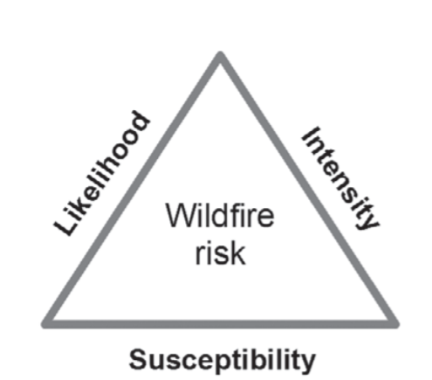 Wildfire risk is the product of a fire occurring (likelihood), the associated intensity of the fire, and the effect of the fire on HVRAs. Mitigating any of these factors would decrease the likelihood of wildfire risk.
* Fire intensity has a probability distribution.
* Fire intensity is independent of fire likelihood.
* Burn probability: the likelihood of a wildfire at a given point during a specified period.
* It is important to consistently map all HVRAs over the entire spatial extent of analysis.
* Variables already included:
  + Fuel Type
  + Slope
  + Access
  + Weather
* Need historical wildfire occurrence data
* Need to consider fires that are 10-20 miles away
  + Potential for strong winds to spread fire more than 20 miles.
* Solar radiation (illumination):
* Is the cost reasonable for the homeowner and Farmer’s Insurance?

**Potential Variables to Consider:**

1. Canopy fuel characteristics:
   1. Canopy base height
   2. Canopy bulk density
   3. Surface fuel moisture content
2. Distance to nearest neighbor (meters):
   1. Distance to nearest road (m)
3. Distance to nearest body of water (km)
4. Slope, Aspect, and Elevation:
   1. Elevation:
      1. Shuttle Radar Topography Mission Digital Elevation Model
5. What is your house made of?
   1. NFPA codes
      1. (SRTM) (DEM)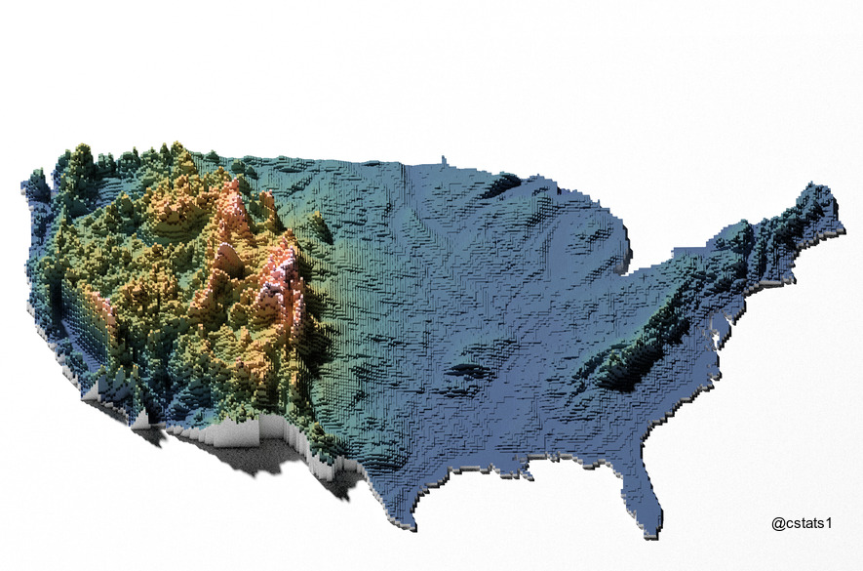
6. Fire suppression covariates:
   1. Firefighting effectiveness
7. Aspect (degrees):
   1. Which direction is your house facing?
   2. Derived from DEM using ArcGIS Spatial Analyst
   3. N (337.5°–22.5°), NE (22.5°–67.5°), E (67.5°–112.5°), SE (112.5°–157.5°), S (157.5°–202.5°), SW (202.5°–247.5°), W (247.5°–292.5°), NW (292.5°–337.5°), F (flat)
8. Number of fires since 2000 / Time since fire (years)
9. Primary building material
10. Population Density (people/km^2)
11. Lightning Strikes:
    1. NOAA
    2. During these two months (July and August), 91% of the total fires were lightning caused (Conedera et al. 2006)
12. Neighborhood Characteristics:
    1. More industrial/farming areas more likely to burn due to human error.
    2. Fertilizer sales within a region by Home Depot / Lowe’s

**Sources of Report:**

<https://www.fs.fed.us/rm/pubs/rmrs_gtr315.pdf>

<https://www.firelab.org/sites/default/files/images/downloads/ArcFuels-help/Content/02Toolbar/05-05%20-Risk.htm>

<https://www.kaggle.com/captcalculator/wildfire-exploratory-analysis>

<https://landfire.cr.usgs.gov/viewer/>

<https://www.fs.fed.us/psw/publications/knapp/psw_2017_knapp001_estes.pdf>

<https://www.ncbi.nlm.nih.gov/pmc/articles/PMC5313183/>

<https://hal.archives-ouvertes.fr/hal-00860797/document>

<https://twitter.com/cstats1/status/1326571601765216257>